BioKatalyst Member Application Form

Updated in June 2023

Dear applicant,

Thank you for your interest in joining BioKatalyst. BioKatalyst is a nonprofit professional organization of American business leaders with Chinese heritage focused on the commercial areas of life sciences industry in the US and globally.

BioKatalyst Vision and Mission

Vision:

Leverage our business expertise to advance the frontier of global life sciences industry, drive innovation and benefit patients.

Mission:

Establish a US-based global platform for life sciences business leaders to:

- Promote member’s career development and business growth through networking, education and more;
- Catalyze business opportunities, entrepreneurship and innovation in the US and across the globe;
- Nurture future leaders by providing mentorship, training and other means of support;
- Enhance our contribution and impact as a professional group on life sciences industry.

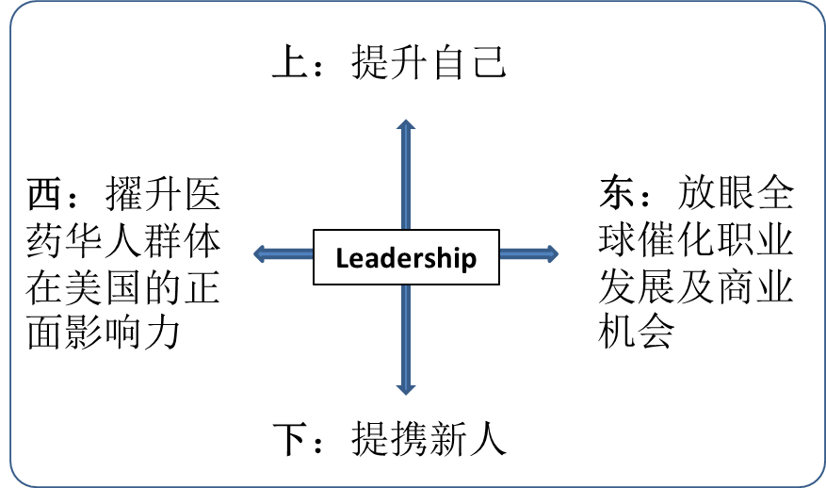
Member Tiers, Criteria and Fees

- Entry Member:
  - Aligned with BioKatalyst vision and mission; and is interested in actively participating in and contributing to the activities of BioKatalyst
  - Paid membership fee of $100 per annum
  - Entry-level membership is limited to young professionals graduated from college within the last 10 years or active BioKatalyst volunteers. Entry Members are encouraged to apply for becoming Senior Member as soon as they meet criteria of Senior Member.
- Senior Member:
  - Aligned with BioKatalyst vision and mission; and is interested in actively participating in and contributing to the activities of BioKatalyst
  - At or above Associate Director level in commercial/management functions in healthcare industries, or VP & equivalent in related industries (financial, legal, consulting etc)
  - Recommended by two current members and approved by the membership committee
  - Paid membership fee of $300 per annum
- Lifetime Member:
  - Qualified as a Senior Member
  - Paid a one-time $2,000 membership fee

Membership Fee Payment Process

BioKatalyst is a non-profit organization. Membership fees and sponsorship/donations could be tax deductible.

Company sponsorship and/or donations secured by one could be counted towards one’s membership fees.

Membership fee payment method choices:
- By Zelle to ID: biokatalyst1@gmail.com (BIOKATALYST A NEW JERSEY NONPROFIT)
- By Online Quickpay to info@biokatalyst.org
- By check, mail to: BioKatalyst, c/o Jansen Wang, PO Box #404, 2468 US Highway 206, Belle Mead, NJ 08502
- By credit card payment (via paypal) on BioKatalyst website: http://www.biokatalyst.org/membership

Upon payment by either of the three methods above, please follow up with an email notice to: info@biokatalyst.org and member@biokatalyst.org

A receipt will be provided for your record if requested.

Membership Commitment

Mandatory commitment
- Pay annual membership fees
- Uphold and abide by group bylaws and guidelines
- Align with BioKatalyst vision and mission

Active engagement
- Participate in voting of officers, board and other committee members
- Participate in member surveys
- Volunteer and contribute to the group activities
- Recruit new members

Please fill in the following application form in the following pages. Your biographical information will not be shared outside of the group without your permission. Some sections will be filled out by recommending current members.

Applicant Basic Information

Select one from the following categories:
____ Entry Member
____ Senior Member
____ Lifelong Member

BioKatalyst Recommenders (for NEW SENIOR members only)
Your Name
Work Location –
city and state
Primary Residence –
city and state
E-mail
WeChat ID
Mailing address
Gender
Job title
Job functions
Organization name

Applicant Biography

Please provide a brief biography that includes your relevant working experience as well as educational background, including undergraduate / graduate educational institutions.

Applicant Acknowledgement

By emailing this application form to BioKatalyst membership committee, I hereby acknowledge that I have read and understood the BioKatalyst membership commitment requirement, and will abide its bylaws and guidelines if admitted as a member.
Signed:

Date:

Recommendations for Senior Members

Recommender One: __________________________________________________
Name: __________________________________________________
Title: __________________________________________________
Organization: __________________________________________________

Recommender Two: __________________________________________________
Name: __________________________________________________
Title: __________________________________________________
Organization: __________________________________________________

